Isles of Scilly Competent Harbour Authority

**Pilotage Passage Plans**

This document is designed to assist in the Master/ Pilot exchange. Not to be used for navigation

‘© Crown Copyright and/or database rights. Reproduced by permission of the Controller of Her Majesty’s Stationery Office and the UK

Hydrographic Office ([www.ukho.gov.uk)](http://www.ukho.gov.uk)).’ This applies to all charts included in this document

**Anchorages**

There are two main anchorages in the Islands, St Mary’s Roads and Crow Sound.

St Mary’s Roadsis the preferred anchorage as its proximity to Hugh Town on St Mary’s and to Tresco, allows shorter tender journeys.

Although St Mary’s Roads provides shelter from winds from SE through E to NW, a Westerly swell can sometimes prohibit tender operations.

When St Mary’s Roads is unsuitable, anchorage can usually be found in Crow Sound as this provides shelter from winds from SSW through W to N and from Westerly swells. However, winds and swells from the South and East can make Crow Sound untenable.

**Channels**

There are two main approach channels for St Mary’s Roads Anchorage:

**St Mary’s Sound:** Generally used for vessels approaching/ departing from the South and East.

Although narrow, the channel is short and subject to visibility, there is a good visual lead.

A draught limitation is in place for vessels transiting St Mary’s Sound (see later page)

A pilot must always be on board vessels that are subject to compulsory pilotage, when transiting St Mary’s Sound.

**North West Passage:** Generally used for vessels approaching/departing from the North

The North West Passage is a wider and deeper channel than St Mary’s Sound

**Crow Sound:** A straightforward approach for all vessels entering the Crow Sound Anchorage, or for smaller vessels approaching from the East transiting Crow Sound to St Mary’s Roads at high water.

**Choice of Anchorages and Channels**

Pilots advice should be sought on each occasion as to which is the most suitable anchorage.

Similarly, Pilots advice should be sought in selecting the approach channel to St Mary’s Roads. As well as the limitations of the channels, boarding conditions may have to be taken into consideration.

On some occasions pilots may finally assess the two anchorages shortly before arrival. In these circumstances, a vessel approaching St Mary’s Sound can easily divert to Crow Sound. This is not so easy if the NW Passage is being used.

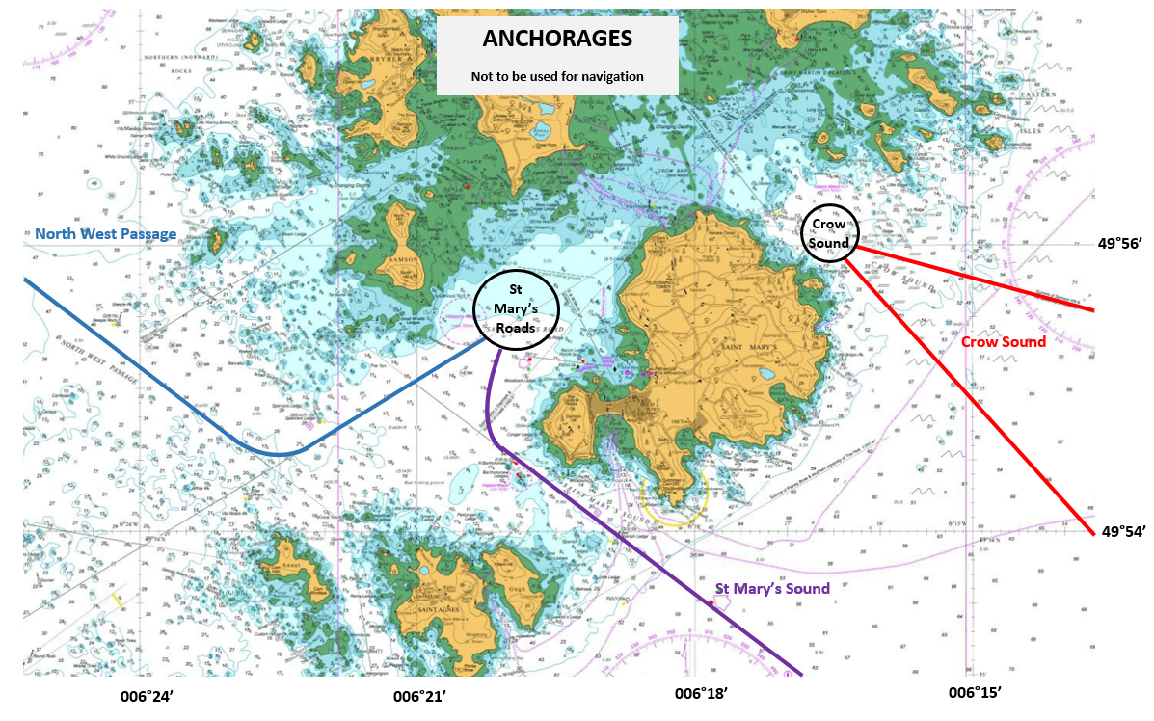

**St. Mary’s Sound**

**Pilot Station:** 49° 53’N 006°17’W

**Minimum Depth:** The minimum charted depth in the channel is 9.9m. However, the channel width at this depth is only 90m. Therefore, the draught limitation is applied to allow a margin of safety to the North East of the channel.

**Draught Limitation:** When visual leads can be seen, maximum permissible transiting draught is 4.7m + height of tide.

When visual leads cannot be seen, maximum permissible transiting draught is 3.7m + height of tide.

**Visual lead:** North Carn of Mincarlo in line with SW extremity of Great Minalto, bearing 307°T

**Tidal Streams:** South East going stream from 2.5 hours after local LW to 2.5 hours after local HW

North West going stream from 2.5 hours after local HW to 2.5 hours after local LW

Tidal streams are generally aligned with the channel, although a cross set can occur in the vicinity of the N Bartholomew and the Bartholomew ledges.

Strong tidal streams set across the entrance to St Mary’s Sound in the vicinity of the Spanish Ledge Buoy.

Full tidal stream diagrams are found on Chart 34.

**Parallel Indexing:** For the main channel (inward course 307°T ) the following parallel indexes are recommended:

The Bow 0.41’ to Port

The Woolpack Beacon 0.13’ to Starboard

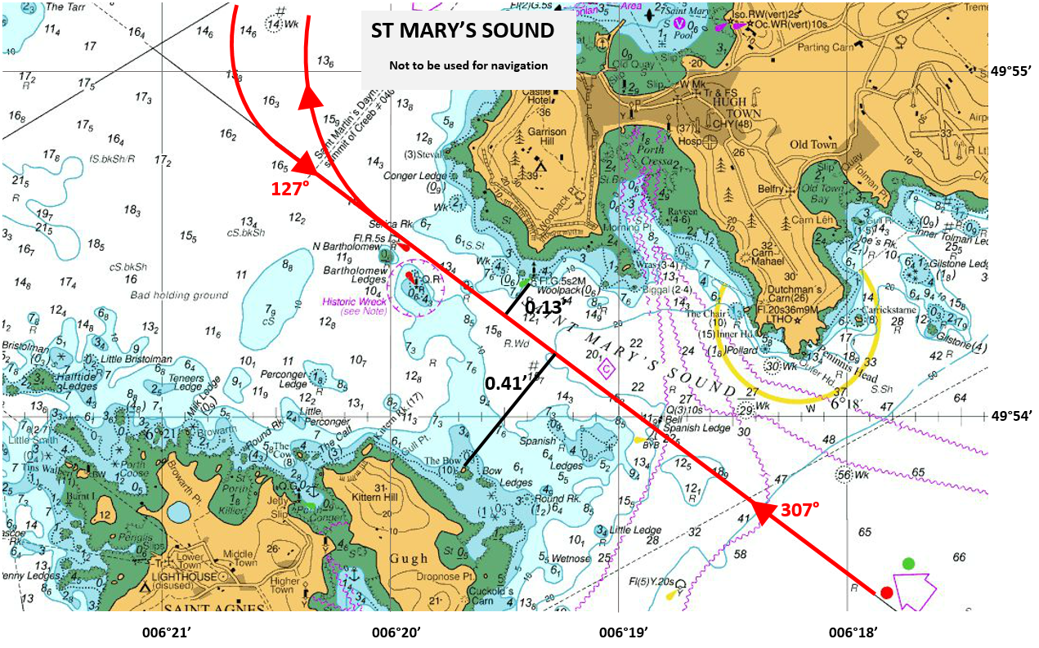

**North West Passage**

**Pilot Station:** 49° 56’N 006°26’W

**Minimum Depth:** The minimum charted depth in the channel is 12.3m. However, there is a 9.4m shoal 3 cables SSE of Spencers Ledge Buoy

Carnbase (depth 3.2m) and Jeffery Rock (depth 0.9m) both lie 4.5 cables SW of the charted track.

**Visual leads:** St Agnes Old Lighthouse in line with Tins Walbert Beacon, brg 127°T

Summit of Great Ganilly just open North of Bant’s Carn, brg 059°T

**Tidal Streams:** Streams are generally rotary, setting North East across the entrance near local HW and South West across the entrance near local LW.

Full tidal stream diagrams are found on Chart 34

**Parallel Indexing:** On Inward 127°T course: Mincarlo 0.95’ to Port

On Inward 059°T couse: Great Minalto and S end of Samson 0.54’ to Port

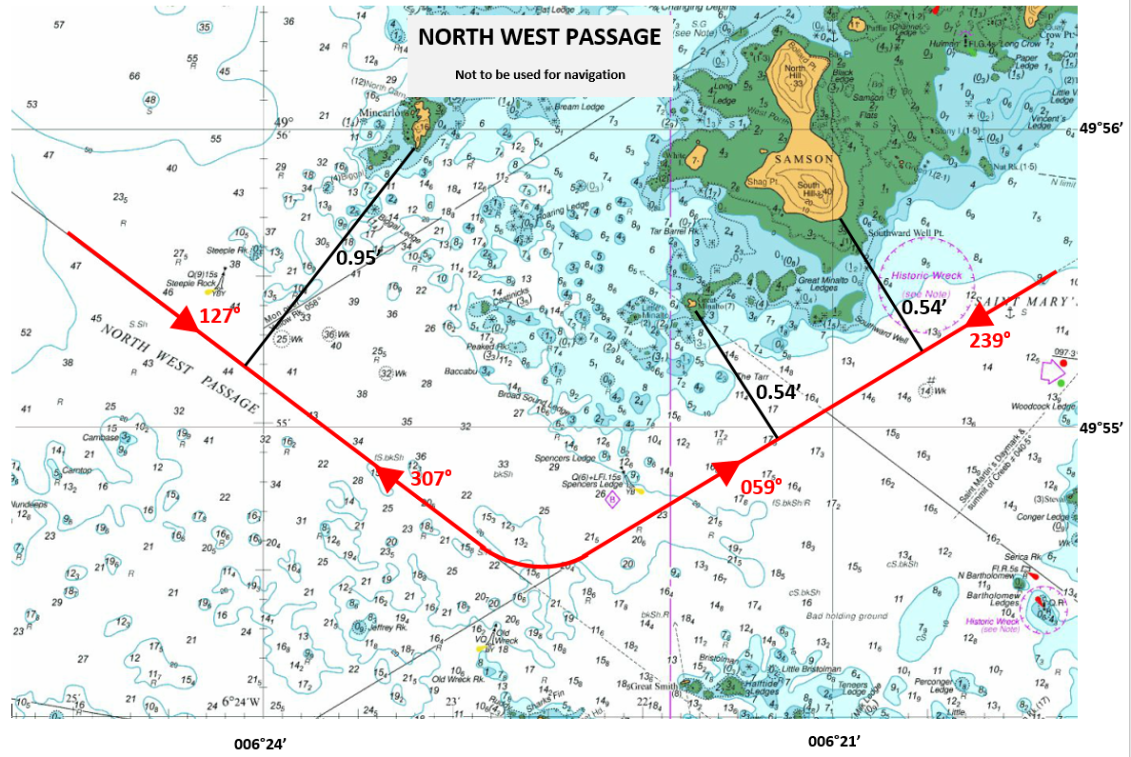

**St. Mary’s Roads Anchorage**

There is an extensive area suitable for anchoring. Good holding ground is limited to the North by a line extending ESE from Nut Rock.

Subject to draft, the Northern part of the anchorage usually gives more protection from the prevailing swells, which come from the quadrant from SW to NW

To the SE of the anchorage, care must be taken to avoid Woodcocks Ledge (depth 2.7m) and the Ridge (depth 5.5m)

Anchoring is prohibited in a restricted area over an historic wreck. This area is 300m radius, centred 0.4’ SE of Southard Well point on Samson.

The bottom is mainly fine sand giving good holding.

The tidal stream is generally from SW to NE on the flood, and from NE to SW on the ebb. However in the Northern part of the anchorage a significant stream flows South between Tresco and Samson for 2 hours either side of HW.

Full tidal stream diagrams are found on Chart 34.

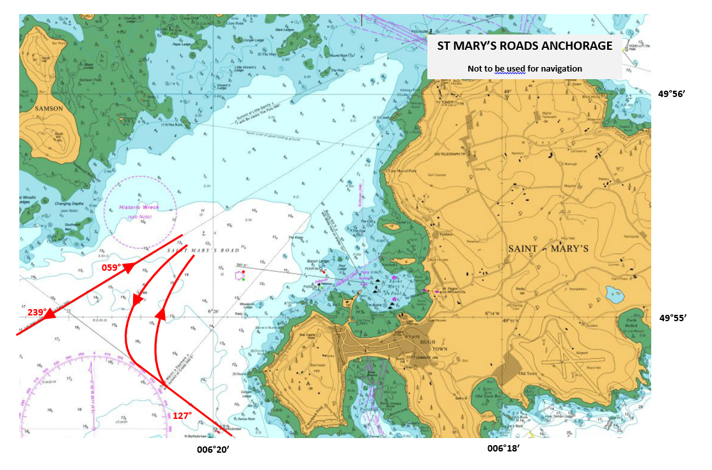

**Crow Sound**

**Pilot Station:**  49° 55.5’N 006°13.5’W

**Minimum Depth:** The minimum charted depth in the channel is 12m, at the anchorage. However the Ridge (lower corner), 1 cable North of the track has a least depth of 9.4m, and there is a rock 2 cables ESE of Innisidgen charted at 7.9m .

Trinity Rock (depth 4.6m) lies 5 cables SE of Great Arthur. This is 4.2 cables NE of the charted track.

**Visual leads:** Summit of Samson Hill (on Bryher) in line with NE extremity of Innisidgen Brg 284.5°T

Or Eastern extremity of Men-a-vaur in line with Western extremity of Guthers Island Brg 319°T

**Tidal Streams:** Strong tidal currents set across the approaches to Crow Sound with the stream on the flood being predominantly North Easterly and on the ebb Southerly and South Westerly.

Full tidal stream diagrams are found on BA Chart 34

**Parallel Indexing:** On Inward 284.5°T course, Tolls Island 0.28’ to Port

On inward 319°T course, Tolls Island 0.23 to Port

**Crow Sound Anchorage**

The tidal stream mainly flows from NW to SE with a weak flow in the opposite direction for 3 hours from LW.

There is an extensive area suitable for anchoring, but the most sheltered anchorage is usually found in the NW part of the anchorage, close to the transit line.

The bottom is mainly fine sand giving good holding.

